**Build and Run a Docker Container for your Machine Learning Model**

**Part-II Documentation**

**Introduction:**

In this assignment, we will build a docker container to perform batch serving of a ML model.

This is a continuation of the TA session demo. You need the following files:

● Dockerfile

● Train.py

● Inference.py

This is the EEG brainwave data that has been processed using statistical extraction. There are totally 1300 rows and 162 columns in the train dataset. The feature Letter is used as the target column. It has 26 classes which is a representation of the 26 alphabets.

**Task:**

train.py

1. Add one more model apart from the one used in TA Session (any machine learning model of your choice) in the train.py file and save it.

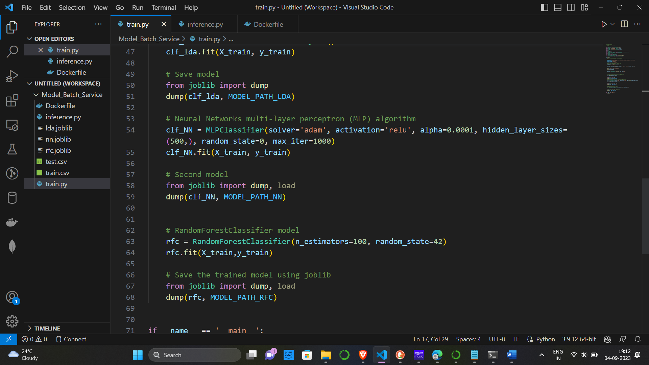

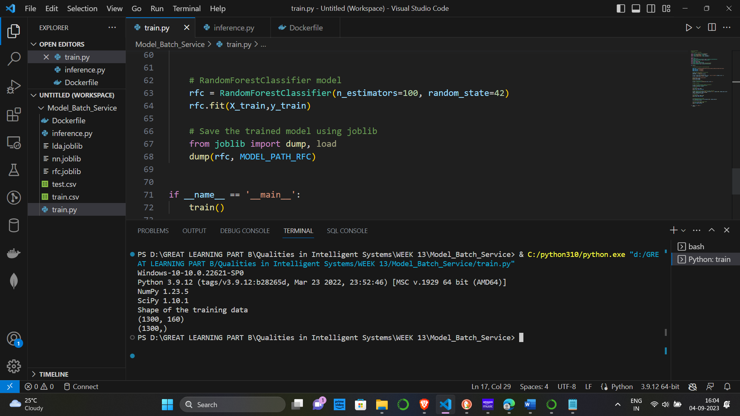

2. Modify the inference.py file to display the output of the above model.

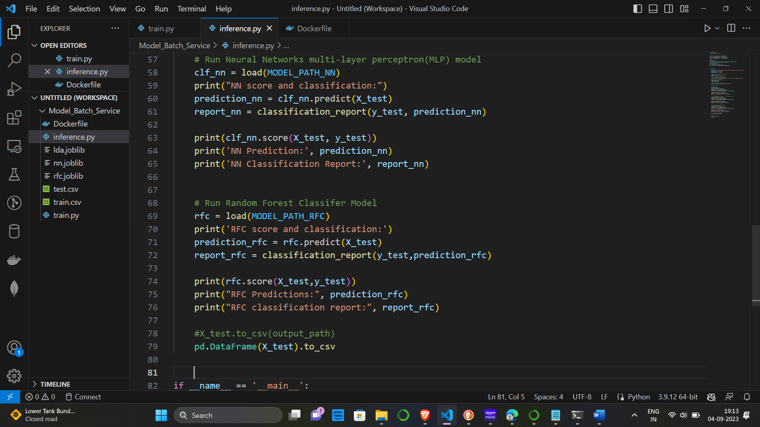

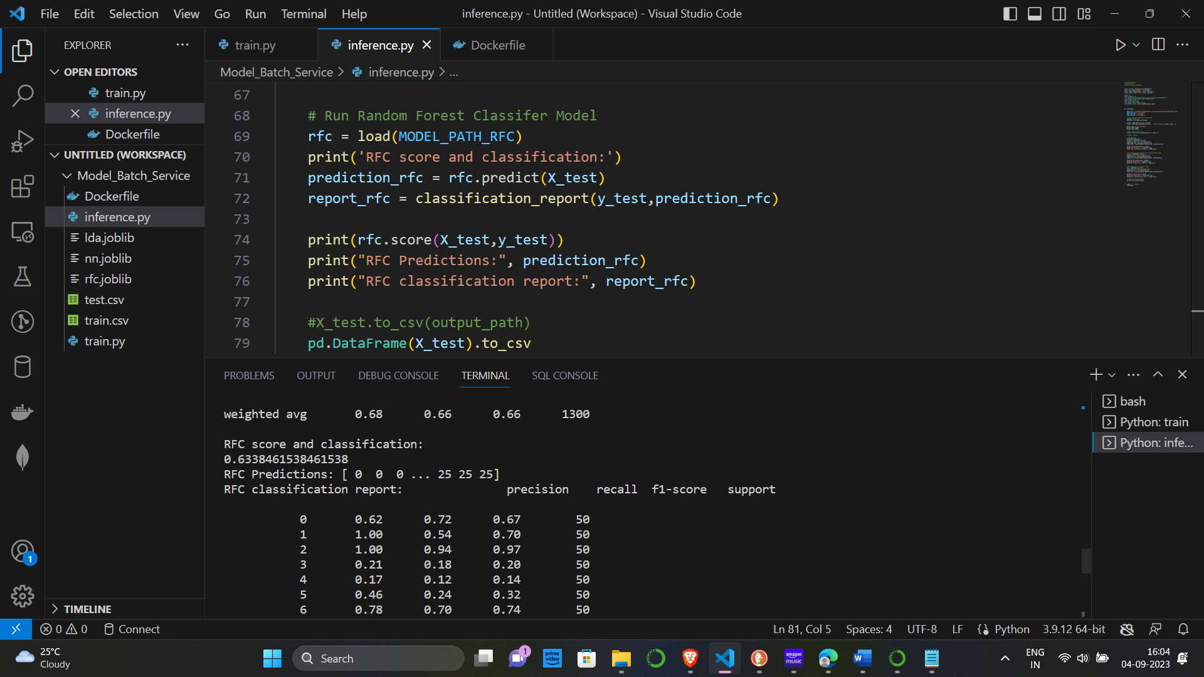

3. Build the docker image of the final application and run it and submit the screenshot of the output.

a. Build the Docker File

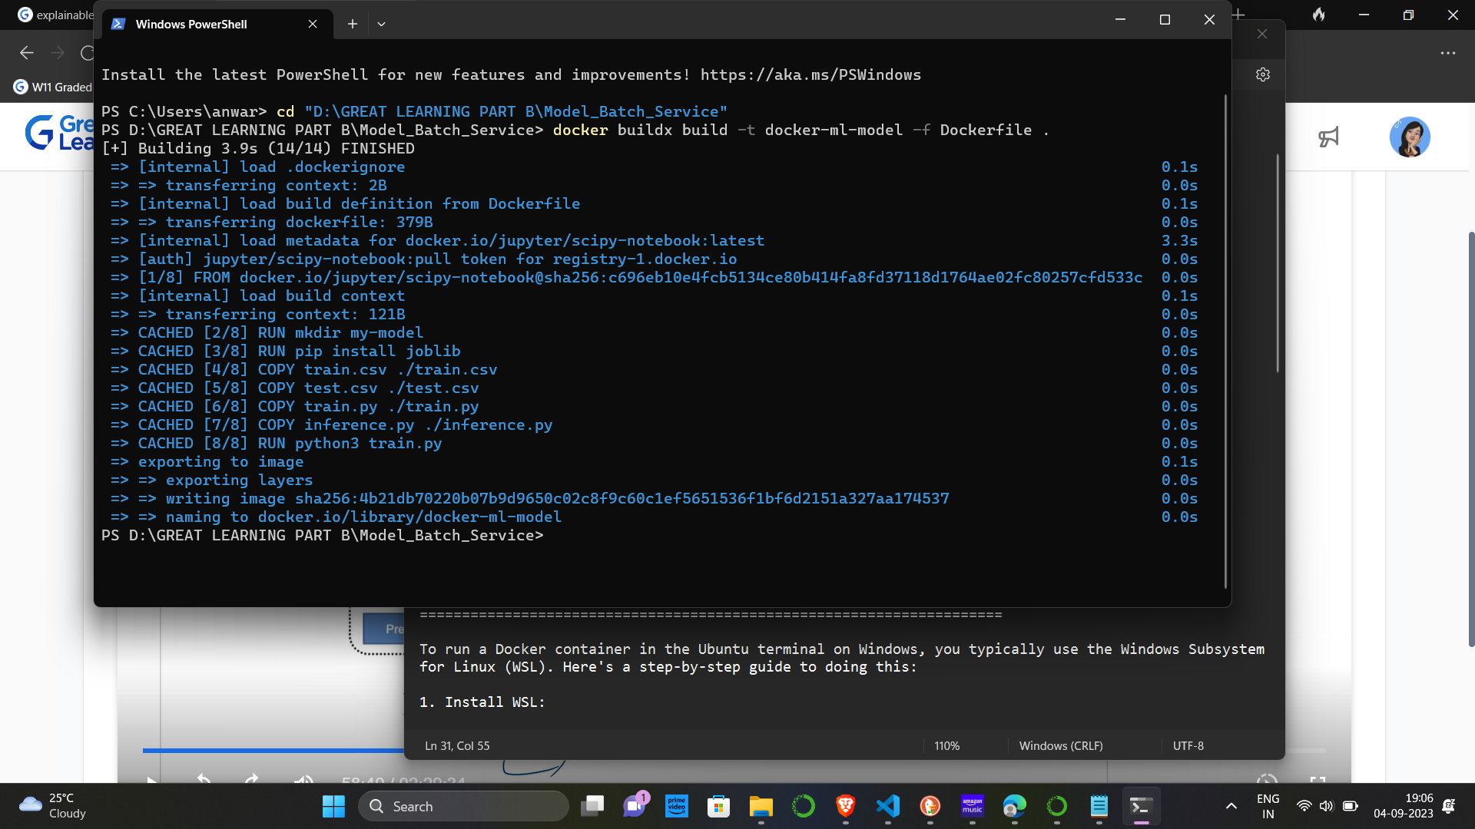

b. Run the docker container

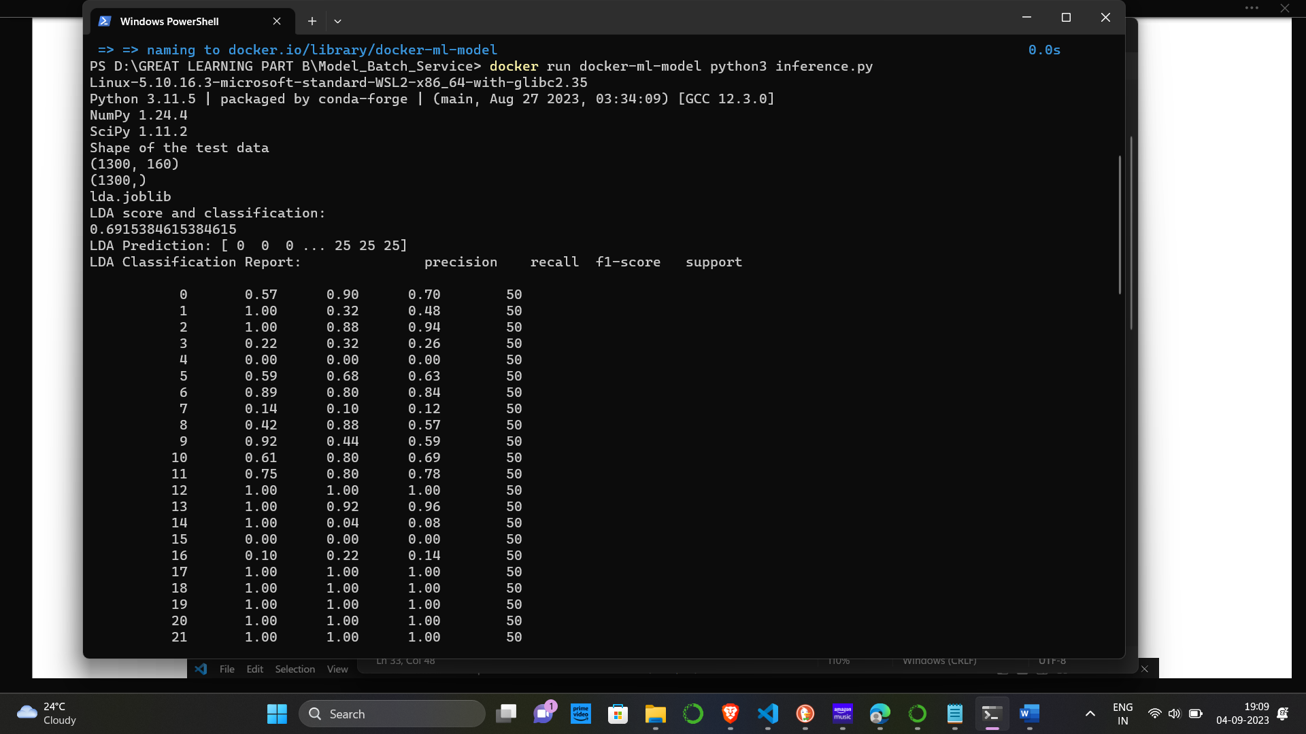

c. Save the screenshot of the output and submit it.

